Contents
- Introduction 3
- Site Specific Information 3
- Pre – construction information 8
- Documentation 9
- Project Implementation Schedule Format 9
- Commissioning, Operation & Maintenance 10
- Quality 10
- Health & Safety 11
- Soil Mechanics and Hydrogeological Studies 12
- Construction Materials 13
- Purchase 14
- Environmental Management 14
- Construction 14
- Contractor’s personnel and organization 15
- Standards, regulations and norms 16
- Services 19
- Enabling works prior to Start of Construction 20
- Construction Start 21
- Environmental Requirement 22
- Sensitive areas 23
- Working Hours 23
- Noise during construction 23
- Construction Traffic Management Plan (CTMP) 23
- Waste Management and Disposal 24
- Reinstatement 24
- Overall Requirements of PV Plant 24

  - Introduction
The Contractor shall engineer, procure & construct a ground mounted, grid connected 10.993 MWp solar photovoltaic farm called Patricia Solar in the municipality of Talagante in the Metropolitan Region of Chile.
The site location is provided in Annex 02.
The requirement for an Environmental Impact Declaration has been waived as demonstrated by the document “RCA” issued by SEA on the 04/11/2021
Construction permit and preliminary works permits were submitted on the 03/21/2022 by municipality Talagante.
Industrial use qualification was granted on the 04/01/2022 by SEREMI Salud Región Metropolitana.
The “Informe Favorable Construcción” was issued by SAG on the 03/13/2022 and by the MINVU on the 01/05/2022.
The grid connection was granted in accordance with the Form 8 filed to CGE on the 11/25/2020.
The Contractor shall ensure that the commitments and conditions included within all the authorizations and permits related to the project are adhered to.
Any variations must be discussed, and agreed with the Owner, in advance of their implementation, as this may require modifications to the original authorizations and permits.
A grid connection offer has been provided by CGE, the Contractor will ensure that all equipment and services (including roadways and accesses) provided are in accordance with the grid connection offer and subsequent design approval.
  - Site Specific Information
The site is located adjacent approximately at 700 m from San Ignacio road Talagante, Metropolitan region, Chile, coordinates 33°42'7.14"S, 70°57'6.08"W.
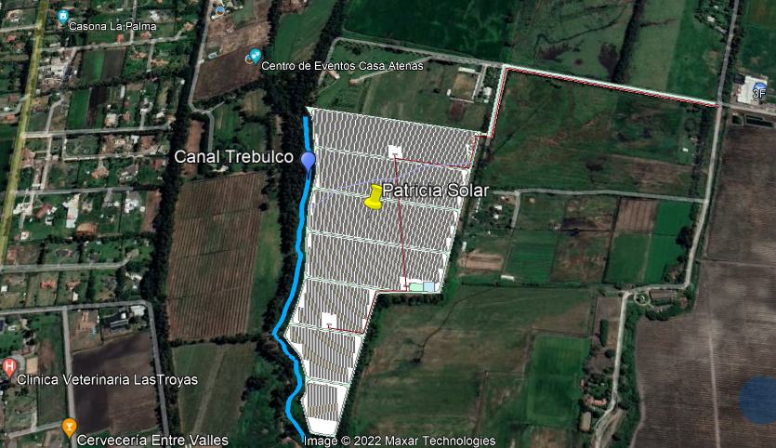
The site comprises of undeveloped greenfield land and surrounded by agricultural land.
The project’s area is delimited approximately by canal Trebulco to the weast and private lands to the north, east and south that will need precise topographic measurements before the Contractor starts the construction works, the results have been made available before the signature of the contract.
Where applicable:
    - Any hazardous or dangerous elements present in the site or its surroundings shall be permanently signed and protected before personnel or machinery enters the site. This include holes, wells, trenches, ditches and any other elements that might imply a hazard.
    - There are no irrigation pipes to be removed prior to accessing the site.
    - All construction works close to the site access and turning points within the site must be fenced off or signposted to avoid damage from vehicles, this should be done by the installation of painted wooden poles whose position and number shall be detailed in the layout.
    - The site has areas where water flows have affected the level of the ground, the existing ditches shall be relocated closer to the site boundaries and orientated to direct rainwater outside of the facility whilst following the natural slope of the terrain.
    - The grid connection cable must be installed underground between the utility poles (location defined in drawings), to the MV Transformer Station. A suitably sized manhole must be installed close to the pole to allow storage of spare MV cable in accordance with the specifications and regulations of the utility company.
    - A permanent access to/from the public road on the northern boundary will be built to ensure trucks can reach all cabins and areas where the equipment will need to be delivered.
    - An appropriate turn radius will be considered during internal road design and construction, recommended 8 and 12 meters internal and external radius respectively. Road slopes (longitudinal) shall not exceed 5 %.
    - Internal roads’ slopes and materials used to build them will consider the correct sanitation of rainwater, both for the roads surface and in their drainage. The evacuation of the waters away from areas with traffic or sensitive equipment must be considered as well by providing slopes to the roads. The relevant geological studies will also be taken into account for the proper functioning of the road during its useful life.
    - Special care must be taken with the public roads that are affected by the movement of transport and cargo and the demands that may be made in this regard, whether due to National Highway issues or environmental issues. Contractor should consider a wetting plan to minimize dust emission, as required by Applicable Permits.
    - Any works in the close proximity to any irrigation channel, ditch or swale (internal or external) must be closely monitored at all times and security buffer kept by all personnel, machinery or temporal material storage. Before starting works all ditches and water channels (internal or external) will be fenced and signed to avoid any personnel or vehicle approaching them.
    - There are potential access routes through the neighboring fields and from the rural paths around the perimeter which leaves this site vulnerable to theft. The storage area must be fully fenced off (by permanent or temporary means) and security staff placed prior to the delivery of items of value.
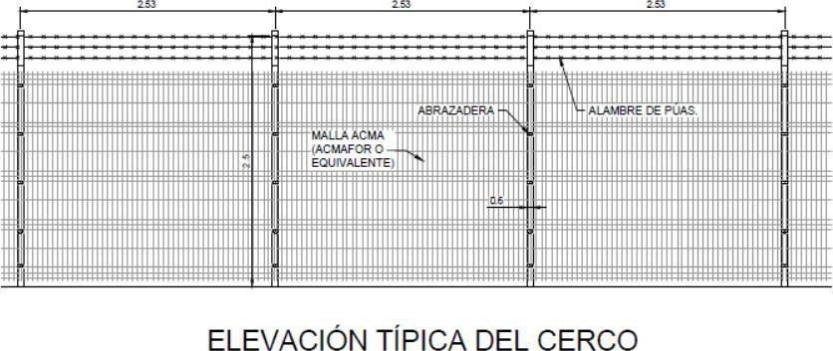
    - The perimeter fence shall be as follows:
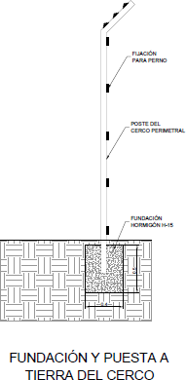
    - Speed limit of 10 km/h will need to be strictly observed on site and road signage should be provided in accordance with the regulations and permits from the Municipality, “Vialidad” and “Ministerio de Obras Públicas” in all the accesses.
    - All design, work practices, materials, components and warranties shall be appropriate for the environment and location to ensure a system longevity of at least 25 years for the ambient conditions of the site.
    - The ground will be reinstated and levelled, when disturbed, to avoid tripping risk and allow grass to grow, using the appropriate machinery, to maintain control of the dust.
    - The minimum elevation of electrical equipment and cabins will be recommended by the flood analysis of 25 years of Flood Risk Assessment (FRA) and according to structural studies. Steps must be provided to access the building's doors, in accordance with local requirements.
    - Auxiliary equipment that requires a power supply will be powered from the auxiliary power supply box which is located close to the auxiliary transformer provided.
    - A traffic management plan will be defined before the start of construction to minimise traffic disruption within the plant and its surroundings.
    - In addition to the switching and metering equipment installed by the utility on the connection poles a switchgear housing will be provided inside the transformer container.
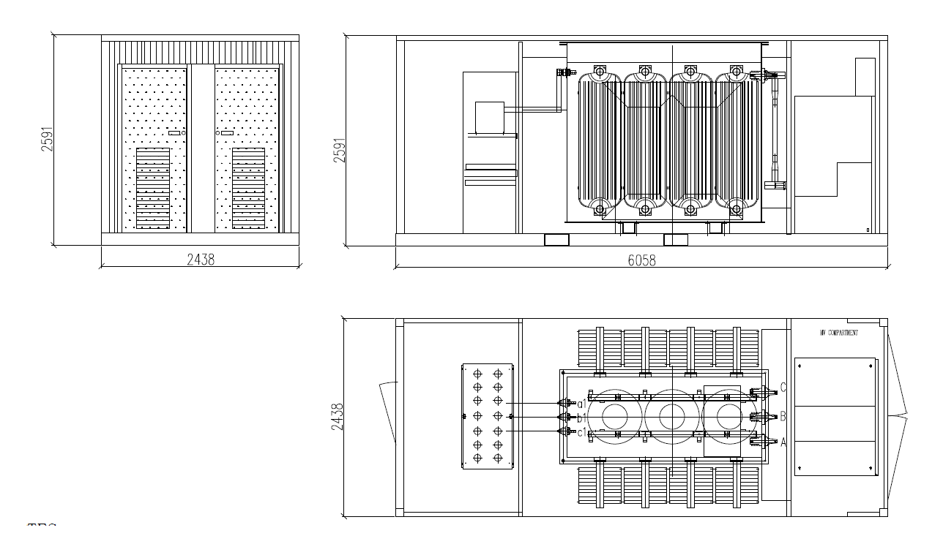
    - A cabin with monitoring compartment and storage room will be installed following prescriptions from authorizations and permits.
    - A fenced area to store non-dangerous waste will be built in accordance with the authorizations and permits.
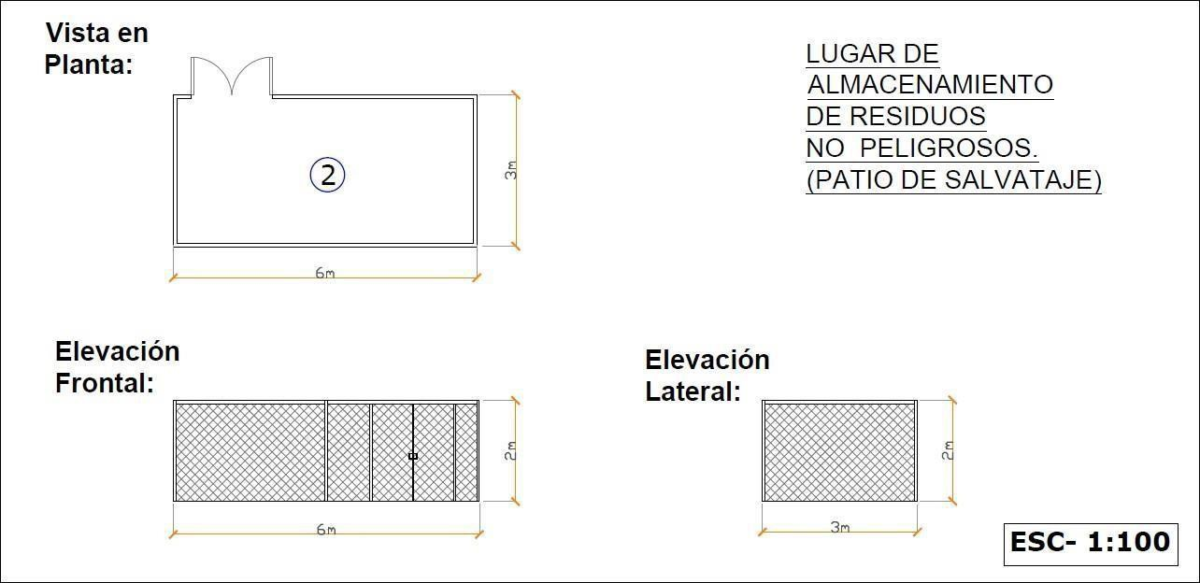
    - Maximum areas occupied by each equipment should be in accordance with the applicable permits.
    - All Applicable Sectoral environmental permits should be considered.
  - Pre – construction information
The information in this document and other information is pre-construction information, provided towards the discharge of the Owner’s duty under the H&S regulations, to ensure that every person involved in the design and every contractor who has been or may be appointed by the Owner, is provided with relevant information.
This information will be updated fortnightly as the project proceeds and consists of
- Information about or affecting the site or the construction work;
- Information concerning the proposed use of the structure as a workplace;
It is a legal duty for the Owner to provide this information and it is provided:
- to ensure so far as is reasonably practicable the health and safety of persons
  - engaged in the construction work,
  - liable to be affected by the way in which it is carried out, and
  - who will use the structure as a workplace; and
- to assist the Principal Contractor, their designers and contractors —
  - to perform their duties under the H&S Regulations, and
  - to determine the resources which they are to allocate for starting, managing and delivering the project.
Failure to implement actions as specified:
- in this document,
- in subsequent documents issued by the Owner or H&S manager as ‘Pre- Construction Information’
- or to remedy issues of failure to implement actions required by the pre-construction information that are notified to the site manager by the Owner or H&S manager within 7 days of notification will be considered to be a breach of H&S regulations.
If circumstances during the construction impact on the ability to implement or respond to pre-construction information this must be discussed with the specified Owner’s team representative and any variation recorded in writing by an update to the Construction Phase Plan.
  - Documentation
All design and as built documentation shall be provided in electronic and paper formats when requested. The Contractor warrants to the Owner that the Works have been designed and engineered using all reasonable skill and care as may be expected of a properly qualified designer of the appropriate discipline(s) for such design, experienced in carrying out design of a solar park similar in scope, nature and complexity as the Solar Park and on a similar site or at a similar location to the Site, and in compliance with this Contract, the Applicable Permits and Applicable Laws.
Documents provided in electronic format shall be delivered in PDF format and also in editable form such as:
    - Microsoft Office 2010 (or later version) formats (Word, Excel, PowerPoint, Access…)
    - AutoCAD (2010 or later version)
For PDF documents where A4 size are will be not enough to appreciate all the details and read all the letters, such as layouts and maps, bigger document sizes must be designed to be printed in A3 format.
Emails must be headed in the subject field as follows:
Project – Topic – Document / Task
Example: [_]:
Emails relating to design and construction should be addressed to the person(s) from whom action is required and copied to all members of the Owner’s team as specified in the Owner’s team document for this site.
All documentation will be controlled using a documentation control process. A master schedule of all documentation will be issued detailing the document title, the current (latest) issue level and date of issue of each document. It is the contractor’s responsibility to ensure that all documentation being used is at the latest current level.
  - Project Implementation Schedule Format
The Project Implementation Schedule must be delivered as a Gantt Chart and delivered in electronic format.
The Contractor may complement said Gantt Chart, with additional activities and stages to better reflect its work plan. For preparing the Master Program for the Execution of the Works, the Contractor must consider the Works and/or Services of the Contract will begin once the Notice to Proceed has been issued.
The Contractor must provide a detailed program of all the activities of the project, from the installation of works, the detailed engineering, the local and foreign purchase processes, the dispatches of said purchases, and their transportation to Chile and to the site of the works, construction programs, and assemblies of all kinds, start-up and receptions.
The program must explicitly indicate each and every one of the key milestones of the Contract. The advance milestones must be approved according to the Contract.
  - Commissioning, Operation & Maintenance
As defined in Annex 9, the Contractor must develop all the plans and documents required for the total and complete definition of the processes of commissioning, reception, operation and maintenance, such as those indicated below, without this list being exhaustive:
- Prepare and deliver, in coordination with the Owner, all documents, protocols, forms, etc., necessary for the proper commissioning of each of the parts of the plant, the different stages and systems of this, the start-up, and the different phases of receptions.
- Control, operate and maintain all project facilities, included in the scope of services, while the Owner has not received the Plant.
- Preparation of documents to support the training of the operation and maintenance personnel of the Owner (if applicable).
- Prepare a detailed plan for the execution of assembly tests as appropriate, operational tests, guidelines and start-up procedures for the project facilities.
These documents must be delivered to the Owner for his knowledge, as appropriate during construction and/or purchase of equipment and materials.
  - Quality
The Contractor must have a Quality Management System that is reasonable acceptable by the Parties and must prepare and submit a Contract Quality Management Plan that includes all the required activities that will allow the Company to administer, control and insure the Contractor, Processes and deliverables of the subContractor.
The quality of the plant and its delivery influences external perceptions of the Owner’s corporate reputation, as such the quality requirement is threefold:
    - Quality of the construction process,
    - Quality of the materials and product used and
    - Workmanship quality.
The construction process must comply with all applicable Chilean laws that relate to the construction.
Every component of the PV Plant must meet the minimum quality and warranty standard in compliance with applicable laws, industrial standards, or codes according to Listed Standards in Section 15 of this Annex.
Equipment must be completely new, although using containers refitted as Control Rooms will be allowed, and never previously been used or installed in other systems. The manufacturer’s warranty on the components should not be shorter than the industry standards.
In addition, the Contractor shall provide, at the Owner´s request, an inverter warranty extension up to 10 years to be paid by the Owner.
The PV Plant must be free from defects in workmanship of civil work, assembly, installation, wiring, start-up of devices, and commissioning.
The Contractor’s warranty on the construction workmanship should not be less than 2 years from the date of PAC.
  - Health & Safety
The PV Plant must be designed and constructed in compliance with all applicable health and safety laws, HSSE Plan, regulations and codes of practice.
The design and construction is subject to the applicable regulations in Chile. The Contractor will act as the H&S Responsible under Chilean regulations and is therefore responsible for health, safety and welfare arrangements on site and must liaise with the H&S co-ordinator regarding initial and ongoing design.
Prior to commencement of any work on site, the Contractor must read any pre-construction information provided by the Owner and/or H&S Coordinator and confirm his understanding of the requirements in writing.
The principal objective of the HSSE Plan shall be to protect the life, health and safety of all personnel The HSSE Plan must identify possible risks for the personnel while carrying out the Works (construction and operation), and it must include a “risk matrix”.
The Contractor must identify and install, for construction and operation phase, appropriate HSSE Signal in the PV Plant.
All Contractors on site must have at least one representative (team leader) who is fluent in Spanish.
Key documents from the planning process have been provided as part of the EPC contractual negotiations and as pre-construction information.
Some of the applicable laws are:
- Ley Nº 16.744 sobre accidentes del trabajo y enfermedades profesionales, sus modificaciones y los reglamentos dictados para su aplicación. Entre otros:
- DS 101 del Ministerio del Trabajo y Previsión Social. D.O. 7 de junio de 1968, y sus modificaciones que aprueba el Reglamento para la aplicación de la ley Nº 16.744.
- DS 40 del Ministerio del Trabajo y Previsión Social. D.O. 7 de marzo de 1969 y sus modificaciones: Reglamento sobre Prevención de Riesgos Profesionales.
- DS 54 del Ministerio del Trabajo y Previsión Social. D.O. 11 de marzo de 1969 y sus modificaciones: Reglamento paro la Constitución y Funcionamiento de los Comités Paritarios de Higiene y Seguridad
- DS 206 del Ministerio del Trabajo y Previsión Social. D.O. 24 de octubre de 1970: Modifica el Reglamento de Comités Paritarios de Higiene y Seguridad, agregando la Promoción y Adiestramiento de los trabajadores
- DS Nº 594, D.O. 29 de abril del 2000 y sus modificaciones: Reglamento sobre Condiciones Sanitarias y Ambientales Básicas en los lugares de trabajo
- DS Nº 54/69 Ministerio del Trabajo y Provisión Social: Constitución y funcionamiento de Comités Paritarios de Higiene y Seguridad.
- DS Nº 40/69 Ministro del Trabajo y Previsión Social Prevención deRiesgos Profesionales.
- DS 76/2006 Ministerio del Trabajo y Previsión Social: para la aplicación del artículo 66 bis de la ley 16.744.
- Ley Nº 18.290, del Tránsito
- Decreto 298 y todas las disposiciones legales vigentes y normas chilenas oficiales sobre clasificación, identificación, transporte, almacenamiento y manipulación de Sustancias Peligrosas. Ley Nº 19.300 Bases Generales sobre Medioambiente.
- Any other applicable Chilean law
  - Soil Mechanics and Hydrogeological Studies
The design of foundations, roads, and structures. shall be in accordance with the soil report presented in Annex 3.
Clarifications to Annex 3:
1.- For MV Stations design, the standard/code ETG-1020 de ENDESA shall be applied.
2.-Foundations for buildings will comply with section “7.2 Fundaciones superficiales de la Norma NCh433 Diseño sísmico de Edificios”. Maximum ground tensión and minimum foundations value will be used.
3.- Safety factors for slip and roll will be calculated based on seismic standards 433 and 2369 if applicable.
4.- Minimum foundation seal level (“nivel de sello de fundación mínimo”) will be obtained and included in the calculation of the foundations.
The study will be carried out by a competent and qualified entity, and the tests or tests that are required must be certified by a laboratory.
These certificates must be delivered to the Owner for their information and review, without the latter being obliged to make a decision on the matter.
A hydrological study, as reasonable required by the Owner depending on site-specific requirements and conditions, should be available in order to ensure that the design of the plant, as well as its equipment and components, are able to withstand the conditions of both moisture and run-off. The hydrology, if required, must be calculated by external party and the relevant works designed, for a return period of 25 years.
Regarding the internal roads of the project, routes of circulation should be adjusted to the local regulations applicable to rural roads, paths and tracks (without asphalt), for the loading of design to be considered and in accordance with the permits.
Design loads must correspond to traffic in the interior roads of vehicles (cranes, trucks) that are necessary to mobilize the heaviest load considered by the project.
The internal roads must consider the correct sanitation of rainwater, both on the platforms of the roads, and in their drainage and evacuation of the waters outside the passage areas by selecting inclinations and appropriate materials.
  - Construction Materials
All materials must be certified in their quality and must comply with all current Chilean regulations.
No second-hand materials, with deficiencies or without certification, will be allowed in any of the construction stages.
Concrete: In case the concrete is made on the ground, all the components must comply with the relevant regulatory requirements and the structural strength of the concrete, must be certified by a certified laboratory. The test and sampling protocols must conform to Chilean standards. All inputs (cement, aggregate, reinforcement, additives, etc.) must be of the required quality and of known and authorized origin.
In the event that the concrete is purchased from a recognized premixed concrete supplier, the certificates of said company must be presented that endorse the materials used and delivered at the construction site.
Reinforcing Bars: All the steels used will be of first quality, certified by the competent body and must comply with current Chilean regulations associated with their use and quality. The materials destined for the union of structural elements must be of the highest quality and must comply with all Chilean and international associated regulations.
No second-hand or reused items will be allowed, as described in the body of the contract.
Others: Any material used in the construction of the plant, in any of its stages, must be of the highest quality, coming from a well-known and legally authorized source. All materials must have certificates of suitability for the use to which they are intended, endorsing this with the certificates that are necessary, which will have been carried out by certified laboratories and competent personnel. The Chilean regulations and their restrictions must be complied with at least in all stages of the process and for all the components that are involved.
The certificates must be delivered to the Owner for their information and review, without this implying approval or consent in their use.
  - Purchase
The Contractor shall be exclusively responsible for the supply of all materials and equipment, inside its scope, that are necessary for the total and complete materialization of the installations and the works included within the scope of the Contract.
The main equipment to be used in the Project will be those detailed in Annexes 10 and 11. If any of these equipment or parts are not available in the market at the time of placing the purchase orders, these may be replaced with prior authorization from the Owner, by equipment of equal or superior quality and standard. Any cost overruns that this replacement could entail must be borne by the Contractor.
The Contractor must submit to the Owner´s knowledge of the technical specifications of manufacture and assembly of the materials and equipment that will be used and are provided by it.
The Contractor, for the materials supplied in its scope, shall be responsible for all stages of the supply, dispatch and transportation process, from manufacturing, factory testing, transportation to port, insurance, maritime or air transportation, loading and unloading at ports, rights and expenses of hospitalization, transfer from the port of arrival to the site, etc.
The Contractor shall be solely responsible for ensuring that the materials provided are new, although using containers refitted as Control Rooms will be allowed, undamaged and fully meet the requirements detailed in drawings and documents or, failing that, that they are of the highest quality in their kind. The Owner reserves the right to request quality certificates, at any time, of the materials and equipment used in the work. To this end, the contractor must schedule and execute the inspections during manufacturing, testing and subsequent receipt of supplies ensure that the sup. The Owner reserves the right to carry out additional inspections on his own, or to entrust this service to third parties, to plier complies with all the requested requirements. The contractor must consider in the concept "site installation", the spaces and warehouses required to store, assemble and make repairs as necessary.
The Contractor shall obtain from the supplier and submit to the Owner, for its review an/or approval, the Spare Parts of equipment inside its scope, as indicated in Annex 13.
  - Environmental Management
The Contractor shall comply, in its designs, supplies and services, with the current environmental regulations and provide, manage and maintain all the background and requirements that are necessary for the environmental compliance established in the regulation and environmental permits as in the electro technical codes and in the laws of Health and Safety.
  - Construction
The Contractor will supply all specialized labor, supervision, materials and supplies, equipment, tools, special tools, services, elements for testing and testing, as well as warehousing, transportation, lifting, unloading, reception, storage, distribution and installation, according to the manufacturer's guidelines.
Field activities shall be carried out by trained personnel with the appropriate experience to carry out their work. The Contractor must ensure that the necessary certifications required, by law, for the execution of any activities that require special certification shall be delivered before these works are carried out. Once the installation is completed, a guarantee certificate will be obtained (for the supplied equipment) from the manufacturer as described in the body of the Contract.
The certificates must be delivered to the principal for their information and review, without this implying approval or consent in their use.
The main obligations of the Contractor in this aspect are detailed below, without this list being exhaustive or limited:
- The Contractor shall also be responsible for the correct functioning and performance of the facilities that are in operation and that are involved during the works, its commissioning, its warranty period in operation and the period of responsibility established in the Contract.
- Throughout this period, the Contractor shall be responsible for remedying any defects detected in the Works that affect performance or safety. The Contractor is solely responsible for all methods and construction methods, technical methods, sequences, procedures to coordinate all parts of the work.
- The Contractor must carry out all the works in a continuous manner and with the greatest diligence, in accordance with the construction plan annexed to this contract and their respective revisions.
- The Contractor must execute all the necessary accesses, to the work facilities or to other areas that are associated with the work, in accordance with the designs annexed to this contract and their respective revisions.
- The Contractor shall be responsible for demonstrable damages caused directly during the performance of the Works to both public and private land and roads. The agreements with the owners of the private or public lands to build the accesses are the sole responsibility of the Contractor. The Contractor must maintain all accesses until the Provisional Acceptance Date.
  - Contractor’s personnel and organization
The Contractor must maintain, throughout the development of the Contract, fully organized the activities that are his responsibility, in strict observance of the organizational charts, description of functions and designation of personnel in charge, committed to the Owner. This requirement is applicable at all levels, including:
- Organization of the General Administration of the Contract.
- Organization of the Contractor at the level of associated companies and with engineering companies and suppliers.
- Organization of Engineering Services.
- Organization for the Execution of the Assembly Works, Civil Works, Testing and Site Start-up.
- Organization of the Technical Office and Contract Administration in the Site.
- Organization for the protection of the Environment and Safety at Work.
The Contractor must ensure to the Owner and his team, the total and complete access at all times to the facilities, provided that there is no risk to their safety or health and always observing the instructions of the person responsible for Health and Safety. Any person authorized in writing by the Owner will have access to the works. These persons shall have the right to be present during assembly, testing and adjustment of equipment and commissioning of facilities that do not represent a hazard and will have access to procedures and test protocols and assembly data. Also these people will have access to the places to verify the state of progress of the manufacture of equipment and materials.
The communications within the Contractor's organization must be carried out according to pre-established procedures in the Contract and known by the Owner. In those cases where there are organization manuals and procedures, a copy of these must be delivered to the Owner, as applicable. The Contractor's personnel who participate in activities in the site must express themselves fluently verbally and in written form in Spanish. If this is not possible, consideration should be given, in the value of the offer, to the participation of personnel who can act as interpreters during the entire duration of the Contractor's activities in the field, for assembly, testing and commissioning.
  - Standards, regulations and norms
The Contractor must design, purchase all supplies and develop all the Works and Services, in strict adherence to the provisions of the technical standards and current legislation on electrical installations of high, medium and low voltage, seismic codes, safety for people and equipment, building, construction and environment, as well as any other applicable norm to the Works, that is in force in the Country.
All these regulations will be the one that, in relation to the Works and each part of them, will be applicable and is in force at the time of signing the Contract for the Works or part thereof, which are part of this project. All references in the Contract to published regulations will be understood as references to the applicable edition and in force on the date of signature of the Contract.
If a new regulation becomes effective, after the date of signature of the contract, the Contractor will notify the Owner if it impacts the design or construction planned and prior to the start of the work, if they have not started on the date of publication of the new regulations.
In the Design Criteria, Technical Specifications and other documents, the Norms, Regulations and Standards that are applicable to the equipment, systems and works that are part of this project are established.
In case of conflicts between the requirements established in the different norms and codes listed, locals will prevail. Afterwards, the international ones will be applied and, finally, if there is no national or international regulation, the specifics of a foreign country agreed between the parties will be applied. Additionally, the Contractor will be solely responsible for verifying the applicability of the standards, standards and regulations of the following list:
CHILEAN STANDARDS
RPTD | Pliegos Técnicos Normativos 1 al 16 del Reglamento de Seguridad en Instalaciones Eléctricas.
NCh4 | Instalaciones de consumo en baja tensión
NTCO | Norma técnica de conexión y operación de PMGD en instalaciones de media tensión.
NCh 2369 | Diseño Sísmico de estructuras e instalaciones industriales.
NCh 432-2010 | Diseño Estructural cargas de viento.
Decreto MINSEGPRES N°4 del 28.10.09 | Reglamento para el Manejo de Lodos Generados en Plantas de Tratamiento de Aguas Servidas
Decreto Supremo MOP N°609, de 1998 | Norma que regula descargas de residuos líquidos a sistemas de alcantarillado
Decreto Supremo MINSEGPRES N°90, de 2000 | Norma que regula todo tipo de descargas a aguas marinas y continentales superficiales
NCh 1333 de 1978 | Norma chilena sobre requisitos de calidad del agua para diferentes usos
Decreto Supremo N°38/2011 | Norma de Emisión de Ruidos generados por fuentes que indica.
Ley Nº 16.744 | Sobre accidentes del trabajo y enfermedades profesionales, sus modificaciones y los reglamentos dictados para su aplicación. Entre otros:

APPLICABLE CHILEAN LAWS
    - DS 101 del Ministerio del Trabajo y Previsión Social. D.O. 7 de junio de 1968, y sus modificaciones que aprueba el Reglamento para la aplicación de la ley Nº16.744.
    - DS 40 del Ministerio del Trabajo y Previsión Social. D.O. 7 de marzo de 1969 y sus modificaciones: Reglamento sobre Prevención de Riesgos Profesionales.
    - DS 54 del Ministerio del Trabajo y Previsión Social. D.O. 11 de marzo de 1969 y sus modificaciones: Reglamento paro la Constitución y Funcionamiento de los Comités Paritarios de Higiene y Seguridad
    - DS 206 del Ministerio del Trabajo y Previsión Social. D.O. 24 de octubre de 1970: Modifica el Reglamento de Comités Paritarios de Higiene y Seguridad, agregando la Promoción y Adiestramiento de los trabajadores
    - DS Nº 594, D.O. 29 de abril del 2000 y sus modificaciones: Reglamentosobre Condiciones Sanitarias y Ambientales Básicas en los lugares de trabajo
    - DS Nº 54/69 Ministerio del Trabajo y Provisión Social: Constitución y funcionamiento de Comités Paritarios de Higiene y Seguridad.
    - DS Nº 40/69 Ministro del Trabajo y Previsión Social Prevención de Riesgos Profesionales.
    - DS 76/2006 Ministerio del Trabajo y Previsión Social: para la aplicación delartículo 66 bis de la ley 16.744.
    - Ley Nº 18.290, del Tránsito
    - Decreto 298 y todas las disposiciones legales vigentes y normas chilenas oficiales sobre clasificación, identificación, transporte, almacenamiento y manipulación de Sustancias Peligrosas.
    - Ley Nº 19.300 Bases Generales sobre Medioambiente.
INTERNATIONAL STANDARDS
IEEE Std 141 (1993) | IEEE Recommended Practice for Electric Power Distribution for Industrial Plants
IEEE Std 242 (2001) | IEEE Recommended Practice for Protection and Coordination of Industrial and Commercial Power Systems
IEEE Std 399 (1997) | IEEE Recommended Practice for Industrial and Commercial Power System Analysis
IEEE Std 519 (1992) | IEEE Recommended Practices and Requirements for Harmonic Control in Electrical Power Systems
ICEA | Insulated Cable Engineers Association Publication P-32- 382
IEEE Std 551 | Calculating Short Circuit Currents in Industrial and Commercial Power Systems
IEEE Std. C57.109-2008 | IEEE Guide for Liquid Inmersed Transformer Through Fault Current Duration
IEC 60076-5 - 2006 | Power Transformer Part 5-Ability to withstand short circuit.
IEC 60364 | Low-voltage electrical installations
IEC/TR 60755:2008, | General requirements for residual current operated protective devices.
IEC 61557 (all parts) | Electrical safety in low voltage distribution systems up to 1000 V AC and 1500 V DC – equipment for testing, measuring or monitoring of protective measures
IEC 62446 | Minimum requirements for system documentation, commissioning tests

  - Services
  - CONSTRUCTION FACILITIES
The Contractor must include in his Offer, the construction facilities, necessary for the correct development of all works and defined in the Permits attached to this Contract.
In addition, the Contractor should consider additionally one desk for Site Inspection Staff:
    - These offices must be enabled during the duration of the work in the site, according to the construction and start-up plan.
    - All furniture must be ergonomically adequate for the work performed by the inspection team.
    - The offices must include electricity service (luminaires and 220 V plugs); and at least two temporary bathrooms as established in the current regulations, which will be located outside the premises of the offices.
The Contractor must provide the services of surveillance, daily cleaning, removal of garbage, and maintenance of the office and bathrooms during the entire period of execution of the works, until it’s dismantling.
  - APPROVAL PROCESSES
The Owner will conduct knowledge taking of all the information. If an approval is required, it will be done in accordance with the provisions of the Contract.
  - PROJECT CONTROL AND COORDINATION
The Contractor shall conduct under its own responsibility and charge, all activities necessary for the planning and control of the activities of the Contract and shall provide, periodically to the Owner, the background and reports defined in this contract for its own information, using the attached formats in Annex 14. This format can be adapted to the requirements of the project. Include as items: Equipment Purchase, Testing and Commissioning).
The Contractor must present the planning and control of the progress of the following activities: engineering, permits, acquisitions (including transportation to the land), contracting of works and services (if applicable), construction, testing and commissioning.
  - OWNER SITE INSPECTION
The Owner or his representative shall have the right to inspect the site and the Contractor must ensure that the Site Inspection team will have full and complete access to all facilities and project documentation at all times when it is safe to do so. The Owner and his representatives must always observe the site health and safety manual when carrying out their inspection visits.
  - AUXILIARY FACILITIES
The Contractor will be responsible for all auxiliary facilities required to support the operation and maintenance of the plant, i.e., potable water plant, wastewater treatment plant and hazardous waste plant. These shall be designed, constructed and operated according to the regulations and the established in the environmental permits and commitments.
  - Enabling works prior to Start of Construction
Material deliveries and site construction will not be allowed to commence until the following conditions are fully met and approved.
Required Documentation
- Agreement from the “Dirección Municipal de Obras (DOM)” local planning authority with respect to the final site layout. This agreement will be requested and provided to the Contractor by the Owner.
- Full name, qualifications (with copies of certificates) and previous experience of the selected site manager, health and safety officer and first aider.
- Detailed design of the unloading area, welfare compound, arrangements for parking, waste management and additional site facilities (as required).
- Construction Phase Health and Safety Plan (CPP) considering the risks inherent with the construction of this specific site in accordance with the requirements of H&S legislation ‘Managing Health and Safety in Construction’ and all relevant guidance (statutory or recommended best practice) required by the Health and Safety Executive (HSE) for managing health, safety and welfare on site during the construction phase.
- Provision of the Site specific site induction document which clearly defines, the access protocol, the Site Rules, the Emergency Action Plan and rendezvous points.
- Confirmation of site security arrangements
- Lifting Plan for site compound.
- A plan for the provision of the agreed signage and a copy of the weekly checklist that will be used to ensure all signs are kept in place and maintained.
- Site Waste Management Plan
- Soil management and protection plan (agreed with the landowner).
- Construction traffic management plan and any other requirements agreed with Highways Authority or municipality.
Required Works
- Install exclusion zones and/or signage around all ditches, obstacles, drainage channels, pedestrian areas to avoid H&S risks.
- Completion of the site access, unloading area and turning area for HGV trucks.
- Completion of the compound in accordance with the approved drawings, together with the siting of a cabin in location agreed (all complete with utilities and sanitation).
- Preparation of facilities for car parking.
- Provide and place required signage to comply with relevant regulations, municipality requirement and guidance from the Owner’s health and safety advisor.
  - Construction Start
The Contractor as Principal Contractor will plan, manage and monitor the construction phase in liaison with the Owner, the Owner’s advisors and contractors. Additionally the Contractor will prepare, develop and implement the Construction Phase Health and Safety Plan, induction and site rules (initial plan completed before the construction phase begins) and issue all contractor management with the CPP and its revisions. The Contractor will issue tool box talks on relevant parts of the plan prior to their commencing work on site. The plan must be updated as the site progresses.
The Contractor must check competence of all their appointees; ensure all workers have site inductions; ensure any further information and training needed for the work and consult with the workers on aspects of health and safety and welfare.
The Contractor must ensure full compliance with permits, authorizations, applicable national and local laws in respect of health, safety and welfare.
H&S Audits will be carried out, without notice during construction. These will identify any H&S breaches and will set out the time scale for rectification of any breaches, either immediately or within the time specified in the contract. Any breaches identified as requiring immediate rectification must be rectified by the site manager within that working day or at the start of the next working day.
The PV Plant shall be equipped with adequate security devices to ensure the workplace safety; however, the system should be designed to operate without the use of external lighting except in the event of an emergency or for maintenance reasons. The Contractor must ensure that health and safety issues are planned, organised, controlled, monitored and reviewed.
Once the enabling works have been fully completed and accepted then the Contractor must submit the following documents to the Owner and Principal Contractor for approval.
- Updated Project Schedule (Gantt chart MS Project)
- Name of main subcontracting companies on site together with the expected weekly manpower deployment and the principal languages of their workforce on site.
- General Risk Assessment Method Statements for all anticipated activities at site.
- Lifting Plan and excavations protocol that will be implemented on site.
- Details of approach to site deliveries.
- Copies of site specific and statutory notices that must be displayed on site together with the weekly checklist that will be used to ensure all notices are kept in place and maintained.
- Minutes from a pre start Site meeting with contractors and written confirmation from each contractor that they have received, understand and will follow the CPP.
- Due to the open nature of the site, however, and the ready access from a number of highways the installation of the perimeter fence along defined external boundaries (at a minimum the northern, western and eastern) should be implemented as one of the first construction tasks.
- Completion of the site access in accordance with agreed drawings and permits.
- Before construction is considered finished, cleaning and grading of the construction machinery ruts will be needed to ensure there are no tripping hazards present and the terrain is suitable for the grass to grow. Top soil will have to be reinstated.
  - Environmental Requirement
The PV Plant shall be designed, constructed and operated in environmentally friendly manner. All equipment should be selected to operate reliable under “normal local conditions”
Ambient temperature 0 to +40°C
Wind Speed Gusting winds (m/s) according to the National regulations and Eurocode.
Snow load Snow coverage (mm) up to according to National regulations and the Eurocode
Rain & Flooding Driving rain and water levels according to National regulations and the Eurocode.
Corrosion Category according to National regulations and the Eurocode
Seismic Area : Zone 3 conforme a la Nch-433
As a minimum, the below requirements should be achieved:
    - Materials shall be recyclable when feasible
    - There shall be minimal ground interference, preparation or topography change
    - Landscape recovery & reinstatement
    - Waste management
    - No toxins are allowed in the system or during construction
    - No lighting, other lighting for security, is allowed for the operation of the plant (temporary lighting can be provided during construction and maintenance).
All Environmental requirements contained in the permits and planning authorizations must be fully observed. Measures for the management of waste, environmental contamination and/ or pollution and the protection of the workforce and visitors from associated risks must be included in the Construction Health and Safety Plan and Site Waste Management Plan and submitted to the Owner prior to the commencement of works.
  - Sensitive areas
Any areas within the terrain that have been identified as sensitive due to the potential of archaeological remains, or for ecological reasons (e.g. tree route clearance) must be fenced off, at the very start of the construction, to prevent accidental intrusion.
Drainage ditches run next to the site, so care must be taken throughout the construction to restrict run off and potential contamination. These areas shall be fenced off to prevent accidents.
All requirements detailed in the authorization documents must be fully observed.
Litter must be prevented from blowing around and collected back to agreed collection points on a regular basis.
  - Working Hours
Working hours should comply with Chilean law.
No deliveries or works which involve significant noise (e.g. ramming of structure posts) shall be carried out outside the Core Hours, however work which does not involve significant noise (e.g. structure assembly) and internal distribution of equipment may be carried out during the extended hours provided that this can be done safely without the need for artificial lights.
  - Noise during construction
Noise emissions shall be as low as possible to minimize the impact on the local residents and should comply with any planning conditions. Any works which involve significant noise (e.g. ramming of structure posts) shall be limited to the core working hours.
  - Construction Traffic Management Plan (CTMP)
The Contractor must fully comply with the Traffic Management Plan prepared in accordance with the requirements from “Direccion Municipal de Obras (DOM)”, “Vialidad”,“Manual de carreteras del ministerio de Obras Públicas” and any additional requests from other authorities Owner made in the interests of road safety and efficient traffic management in the area around the site.
The Contractor will ensure that driver instructions are issued to all subcontractors, logistics companies and any other organisation whose vehicles will travel to the site. The Contractor will operate a control system to ensure compliance with driver instructions by all subcontractors, logistics companies and any other organisation whose vehicles will travel to the site and report incidences of non-compliance to the Owner.
Appropriate signage, to ensure the safe access to the site for both personnel and traffic during the construction phase, shall be agreed with the “Dirección Municipal de Obras (DOM)”, Owner and H&S Coordinator prior to commencement of construction.
Prior to commencement of any site activities a photographic record must be made of all access routes. This photographic record must be repeated at the end of construction to verify any necessary reinstatement work.
  - Waste Management and Disposal
All waste materials must be disposed of in accordance with applicable laws.
At the end of the construction all debris and waste materials must be removed from the PV plant to comply with H&S requirements.
  - Reinstatement
At the outset of the construction the Contractor, Owner and land owner must agree the approach to any excess soil displaced and the Contractor must abide by this agreement.
At the end of construction, a full site clean-up must be performed, any damage to the original infrastructure shall be repaired and the land must be reinstated where damaged.
The full costs for this reinstatement, excluding external roads, must be included within the Contract price unless it is considered an Unforeseeable Site Condition according to the definition in the Contract.
  - Overall Requirements of PV Plant
The PV Plant must be built in full accordance with all the authorization conditions (Annex 4) and meet the Company’s minimal requirements of performance, quality, bankability, reliability, safety and environmental protection.
  - Yield
Considering the historic insolation of this place the plant is expected to produce close to [_]kWh/kWp/year.
  - Performance
The PV Plant must achieve the Guaranteed Performance Ratio.
  - Reliability
Each component shall be of a material and design to maintain its functionality until the end of its service lifetime (25 years) given the local conditions of the site, even after being subjected to temperature cycling, UV, mechanical stressing, corrosion and other deteriorating forces.
Special attention shall be paid to cables, grounding conductors, connection terminals, structures and civil works. The Contractor shall undertake to provide reliability data of all components upon request from the Owner.
The reliability of design is linked to the robustness of the methodology, mechanism and procedures used in design and construction. All design, work practices, materials and components shall be selected to ensure suitability for the environment and location to ensure a system longevity of at least 25 years.
  - Design
The PV Plant must be designed to operate in an “automatic mode and remote connection” producing electrical power for sale to the utility grid, whenever sufficient sunlight is available and minimise the amount of human intervention during normal operation. Furthermore, the plant shall be designed to ensure that the guaranteed performance ratio and availability will be achieved and the operational and maintenance costs will be minimized throughout the system life. The design of all the installations should consider the preliminary studies carried out (Studies of systemic impacts which ones should consider the latest design of the PV plant) and other PMGD.
  - Component Selection
The key components, such as inverters, structures, transformers, modules and monitoring systems must be selected from the List of Authorized Equipment, Suppliers and Subcontractors (Annex 10) in accordance with the specifications detailed in Annex 11.
All components and equipment must meet the prevalent health, safety and environmental requirements of the country where the system will be installed as set forth in Clause 4.13 of the Contract, be certified to meet the EC Declaration of Conformity and be installed in accordance with the manufacturer’s most recent installation instructions.
Solar Modules | The Contractor is responsible for the provision of, unloading and safe keeping of the PV modules once delivered and any modules damaged after delivery should be covered by the Contractor’s insurance.
PV Support Structure | Corrosive category must be assessed by the Contractor before construction and confirmed by the Owner before the beginning of the construction.  Any damage to the hot dipped galvanizing of steel parts shall be repaired with suitable, zinc rich, touch-up paint, specifically designed for this purpose, post-assembly. Note this does not apply to areas reserved for grounding.  After performing a desktop study to evaluate local weather conditions together with onsite topographic, geotechnical, driving pole and pull- out tests the contractor should provide the following for approval prior to commencement.
- Allowable installation tolerances
- Allowable deformation under local wind and snow conditions and thermal loads
- Structural verification, using site specific wind and snow loads, in accordance with Chilean and Euro codes
- Support structure and foundation calculations to verify that the design withstands the uplift.
- Minimum depth of the foundation poles.
- Amount of soil to be moved.
Adjacent module tables/trackers within the same rows must have the common edge aligned, to avoid visual misalignments greater than the acceptable limits defined in the installation manual,
Each row shall be identified at each end, by a UV resistant and waterproof label measuring to be readable at least 10 meters.
Use structure to ensure correct assembly according to module manufacturer´s manual & recommendations (aiming to avoid problems of leveling and separation).
Soil aggressiveness | The Structure or Tracker must be designed to withstand the soil aggressiveness of the site for the entire life of the solar farm.  The solar plant must be delivered without weeds and with all clean panels.
Low Voltage Electrical System (LV) | All applicable electrical safety standards must be strictly obeyed when designing the electrical system sizing and selecting components. In addition, the electrical design must minimize energy losses, increase system efficiency and facilitate O&M.  In accordance with the Flood Risk Assessment recommendations, all ground mounted electrical equipment should be raised at least 300mm above the surrounding area. Appropriate drainage facilities shall be built around the foundations to avoid water flow towards the electrical equipment or cabins.  Cable entries into electrical equipment must be arranged to prevent water entry via capillary action, in general cable entries should always be through the base of the box and sealed with cable glands.  Material surrounding cable entries should be selected (stone or cable sand for example) to prevent water entering cabins or equipment.  Cable colours and connectors shall be in accordance with the applicable electric codes.
DC Wiring | Connections to the module string must be performed using the same connectors as those used by the module manufacturer. Only tools certified by the connector manufacturer shall be used for attaching plugs and sockets to cables on site.  All exposed module and string inter-connecting cables shall be fixed to the module or mounting structure using either UV resistant clips or UV resistant cable ties and restrained to avoid fatigue and wearing.
All cables running behind the solar modules must be protected from direct light.
The bending radius of all cables must be greater than the minimum allowed by the manufacturer of the cable at all times.
All cables must be protected from sharp edges.
Any cable that is not located directly behind the solar array shall be buried, in appropriate conduits (foam or water block solution or equivalent will be applied), at a minimum depth of 500mm and be certified for being installed underground or underwater. Appropriate cable tapes should be used to identify the location of the cable at a maximum depth of 300mm.
All cable ducts should be sealed, with pest resistant sealant such as Quelfire QF2 compound, Cobian Kalasiuk, or similar, at each end to prevent access by animals and insects.
All cables, except for inter-module connecting cables, should be permanently marked at each end with their designation using a permanent and durable, purpose designed, cable marker.
Aluminium cabling is to be used instead of copper where possible and this is to be clearly identified on the layouts.
String cables and other accessories (ties) will be selected according to the local regulations. String cables will be appropriately labelled with UV resistant label.
Cable colours and connectors shall be in accordance with the applicable electric codes. Colour identification will apply only at the end/terminations of cables.
Inverter | If the manufacturer recommended DC/AC ratio, maximum allowed current or voltage, is exceeded within the design then a letter must be provided from the inverter manufacturer approving the design and confirming that there will be no negative impact on inverter warranty or performance.  Inverter commissioning certificate/letter must specify DC power and any AC limitations configured.
Transformer And Transformer Protective Devices | The transformer must include an alarms facility and provide remote indication of oil temperature, oil level and presence of air bubbles and this should be connected to the monitoring system as well as providing automatic isolation of the transformer in the event of an alarm  If an outdoor transformer is used then this must be fenced off to prevent unauthorised access.
Customer switch room | All wiring and connectors within the Customer switch gear must comply with Chilean standards and DNO requirements.
MV Cabling | All MV Cabling must be installed at the specified depths and in accordance with the national regulations. If an alternative installation
method is used then the proposed method will need to be signed off by the Owner.
The location of cables must be recorded (within a tolerance of ±0.5m) and marker tape must be used to provide a warning of the cable existence.
Specific cable trench layouts must be provided.
Appropriate cable tapes should be used to identify the location of the cable.
The overhead power lines should consider the security band according to the regulation, and perform easement contracts where necessary.
Earthing System | All metallic elements of the plant according to the local regulations and standards and the manufacturers, including auxiliary ones (e.g. fence), must be connected to earth in accordance with the earthing connections regulations, the earthing study and the recommendations from the manufacturers.  Permanent identification of all the cables and connections must be done in accordance of the local applicable electro-technical codes. Appropriate colours will be used.
Fence | 2m-high chain-link fence, with 50x50mm mesh, 2.7mm wire thickness plus 40cm of barbed wire on top for a total of 2.4meters or more; it is clearly understood that the fence installed will be always according to the Applicable Law and Applicable Permits.  Manual sliding gate for vehicles.  2.08m x 3m mesh (ACMAFOR or Equivalent)  The fence shall be appropriate to ensure a system longevity of at least 25 years.
Civil works | Photographic reports of the site access shall be prepared prior to and subsequent of construction completion.  Where improvements are required to existing roads to enable the final access to the site then these should be of similar construction and quality to the existing infrastructure.  Internal service roads shall allow delivery of materials and equipment throughout the construction process and provide long-term maintenance access. Should be designed and constructed to minimize dust emission.  The right of way road (“servidumbre”) shall be treated to minimize dust emission.  Any manholes which are in or close to an internal road shall be designed to prevent damage in the event that a vehicle drives over it and must consider water drainage, be suitable for heavy traffic when needed in main and internal perimeter paths, complying with a distance of less than 120 m (Nch4).
 | Civil works must consider Nch 2369 as seismic norm.
Drainage | Due to the likelihood of localised flooding on site, all electrical equipment (inverters, transformers, customer switchgear and monitoring container) shall be installed on foundations raised following Flood Risk Assessment and not lower than 300mm off the ground.  300mm of stone chippings or cable sand should be laid at buildings accesses to provide a dry, clean surface, around cable entry points.
Temporary Fencing | Temporary fencing used during construction should be HERRAS fencing for site entrance, any boundary field gates/ hedge gaps and segregating any secure areas; pedestrian or other suitable barriers for segregating the compound area and excavations. Hazard tape and road pins are unsuitable for this site due to the weather conditions.
Signalling and Signage | Hazard warning signage should be installed during the construction phase and the subsequent operation to warn of the potential hazards inside and outside the plant.  At the entrance of the plant describing all the hazards present and required equipment to enter safely.  All electrical equipment, including but not limited to combiner boxes, inverters, transformers and switchgear, shall be permanently labelled to identify the electrical hazards.  Signage shall be placed around the fence perimeter at 50m intervals and at all gates, to warn of the presence of potentially lethal voltages and that CCTV surveillance is present.  All signalling and its fixings must be UV resistant.  Include Signage and Safety Signs (HSSE) for the construction and operation stage.
Cameras | CCTV coverage must cover the entire perimeter fence and entrance as well as key internal areas including (but not limited to) site offices, gates etc.  Cameras must be located to ensure no blind spots around the perimeter. Every camera must be visible from another one to detect any tampering attempt.  Poles must be strong enough to avoid any kind of movement due to wind forces. They will have 3.5 meters high or more, to difficult any tampering attempts.  Poles are to be installed with a minimum distance of 1 meter from the fence and must be properly connected to the plant earth circuit.  Surge arrester protections for each video signal cable and power supply cable to protect the equipment from lightning storms.  Cameras shall have the capability to see during day and night conditions.
DVR | Must be configured to detect human intrusion inside plant and skipping false alarms due to movement coming from vegetation, wind, animals, insects, rain, fog or snow.  Automatic Remote backup of potential intrusion video will be stored outside the plant (by RCA).  Surge arrester protections from each video signal to protect the equipment from lightning storms.  Software to see all the cameras from remote to be provided.
Surveillance service | Alarm must be able to alert a remote central station service via internet. A backup communicating channel will be used when Internet is not working. If this happens the security centre personnel will check the CCTV to check the situation.  If a live signal is not received for more than 15 minutes the security centre personnel must check the Control Panel of CCTV to check the situation.  After analysing the situation, by checking the CCTV, the security centre personnel must classify the risk and take actions accordingly:  - Contractor must notify Owner, patrol and police within 30 minutes, or as soon as possible, from the first alarm signal.  - If a real intrusion is identified patrol and/or police must be sent to the site if possible within 30 minutes from the first alarm signal.  - If the reason of the alarm is not clearly identified patrol and/or police will be sent to the site within 30 minutes from the first alarm signal or communication problem.  - In case vandalism or not real robbery risk the security centre personnel may decide to activate the sound and light alarm to scare the persons causing the problems. If this is not sufficient patrol and/or police will be sent.  The security company must be able to prove that they have adhered to their walk around every time a patrol is required and as such a method of evidencing their work is needed, with the wand system being most desirable.  The contract with the security company must not contain a waiver of subrogation of a waiver of the insured's rights as Insurance company reserves the right to subrogate against security companies who cannot adequately prove their performance of the walk around and the terms of their security contract.
Weather data measurement | Temperature sensors shall be included to measure ambient temperature and module (cell) temperature. Module temperature sensors will be situated on one of the cells located in the middle of the module.
The exact siting of the Pyranometers and module temperature will be defined as part of the detailed design, but in general shall be as close to the centre of the plant as possible.
In addition, a calibrated cells soiling measurement device should be procured and
installed. The soiling measurement device will allow soiling factor calculations in line with IEC 61724-1:2017.
Monitoring system | Should be provided by Green Power Monitor, AlsoEnergy or Meteocontrol.

  - Reports
The Contractor will be responsible for the approval of the electrical design by the utility and the provision of the required documentation (e.g. harmonic & earthing studies, fault analysis etc.) if requested in the Connection Offer.
The Plant´s design should be provided to the Owner for its review, which will have the time specified in the contract to approve the design or ask for modifications.

